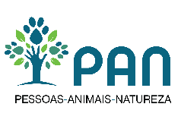

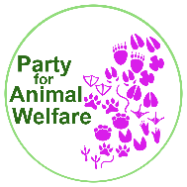
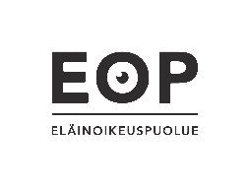
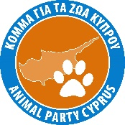

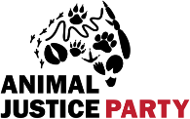
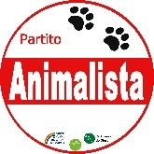

To:
Deputy Minister of Interior Stelios Petsas
gram.anyp@ypes.gr
Please reply to :
Animal Politics Foundation
info@animalpoliticsfoundation.nl
Nieuwezijds Voorburgwal 32
1012RZ Amsterdam
Subject: Elections in Greece

9thof May 2023

Esteemed Deputy Minister of Interior Stelios Petsas,
It has come to our attention that the Greek Supreme Court has banned the participation of the allianceGreen and Purplein the parliamentary elections of May 21, because of a technical error. The error was in the electronic system launched for the first time by the Greek Ministry of the Interior for the registration of candidates for elections.
The Green and Purple alliance acts according to European values of democracy, human rights, compassion and sustainability. The alliance was duly and timely registered. The registration system of their candidates used the electronic registration system launched by the Greek government and sent a proof that the registration was done correctly. Later, however, the participation of the alliance in the elections was cancelled by the authorities because according to the authorities two cells were not filled in the system. Those cells included two numbers both of which the Ministry of the Interior already had in the original hard copy form provided by the Green and Purple alliance, two days before the electronic system submission started. More specifically, the first number was the protocol number that the electronic system didn’t even allow to be filled in, and the second number was the alliance’s registration number already provided by the Ministry in order to get access to the electronic platform.
Greece is part of the European Union and the birthplace of democracy. Excluding democratic parties from the right to participate in free elections just because of a technical error in system used for the first time, does not fit the European values and the rich Greek democratic history. Now is the time for the Greek authorities to show that they take democratic values and the right to free elections seriously.
We respectfully urge you to look at the case again and to allow the Green and Purple alliance to participate in free elections.
Yours sincerely,
Anja Hazekamp, Member of European Parliament (Partij voor de Dieren, The Netherlands)
Christine Teunissen, Member of Dutch Parliament (Partij voor de Dieren, The Netherlands)
Ines Kostic, Animal Politics Foundation
Le Parti Animaliste (France)
Vanessa Hudson, Animal Welfare Party (United Kingdom)
Kyriacos Kyriacou, Animal Party Cyprus (Cyprus)
Tatu Chanth, Eläinoikeuspuolue (Finland)
Robert Gabel, Partei Mensch Umwelt Tierschutz (Germany)
Inês Sousa Real, PAN -Pessoas-Animais-Natureza (Portugal)
Constance Adonis Villalon, DierAnimal (Belgium)
Cristiano Ceriello, Partito Animalista Italiano (Italy)
Bruce Poon, Animal Justice Party (Australia),
Liz White, Animal Protection Party of Canada (Canada)
Gerben Uunk, Party for Animal Welfare (Ireland)
PiniZiser, Tsedek La Kol, Justice for all (Israel)

